DESIGNFLOW AI
Project brief
Interior design CRM, Revit automation, and 3D model studio · 12 October 2026
1. What this project is
DesignFlow AI is a working studio system for an interior design firm. It keeps clients, projects, requirements, tasks, model checks, and reports in one SQL Server database. A web studio, an API, and a Revit desktop add-in all use that database.
A client brief becomes stored requirements. The assistant can propose tasks, but those tasks stay Proposed until an admin or project manager approves them. They do not appear on the task board before that. When a Revit model fails a check, the database opens an issue, assigns the lead designer, marks the project Needs Attention, and writes a notification.
2. The pieces
Part | Where it runs | What it does
Angular studio | http://localhost:4200 | Dashboard, projects, tasks, issues, reports, and the 3D model page.
ASP.NET Core 8 API | http://localhost:5080 | Sign-in, project data, AI, Autodesk token, and the viewer session. Swagger is at /swagger.
SQL Server database | DesignFlowAI on LocalDB | Eighteen tables. The seed data is three projects with users, tasks, and validation results.
Revit add-in | Revit 2025 and 2026 | Ribbon tab DesignFlow AI: sync a model, run checks, show requirements, and queue a translation.
Autodesk Viewer | Inside Model studio | Shows a translated 3D model in the browser. Revit itself stays on the desktop.

3. Who sees what
The same studio changes its pages and numbers from the signed-in role.
Role | Seeded person | What they see
Admin | Ava Kapoor | The full studio: clients, budgets, approvals, automation, and settings.
Project manager | Maya Chen | The same delivery tools as an admin, including task approval and client records.
Designer | Arjun Mehta, Lena Ortiz | Projects they lead, tasks and issues assigned to them, the model, and reports. No client list, budgets, or approvals.
Client | Rahul Sharma, Sofia Alvarez | Only their own project, the 3D model, and the report. No task board, studio issues list, or AI assistant.

Every seeded account uses the development password DesignFlow123!. The API replaces the placeholder hash with a real password hash the first time it starts in Development.
4. How the work moves
Brief. A manager or designer saves scope on the project, or the assistant reads a brief and stores rooms, style, and constraints as requirements.
Plan. The assistant can write a task plan. Those rows are Source = AiProposed and Status = Proposed. A manager approves them onto the board or rejects them so they never become active work.
Model. The Revit add-in syncs the file name onto RevitModels and posts four checks: doors missing a fire rating, rooms without names, unplaced rooms, and missing sheet parameters. Only a Fail creates an issue.
View. Model studio asks the API for a viewer session. The API keeps the Autodesk secret, uploads or reuses a translated model, and the browser loads the Autodesk Viewer. A project that already has an Autodesk URN shows that model instead of the sample room.
5. Entity-relationship diagram
The diagram below is the DesignFlowAI schema. A project sits in the middle. People sit above it. Model checks sit below it. The bottom row is the record of jobs, drawing issues, approvals, notifications, AI commands, and audit history.
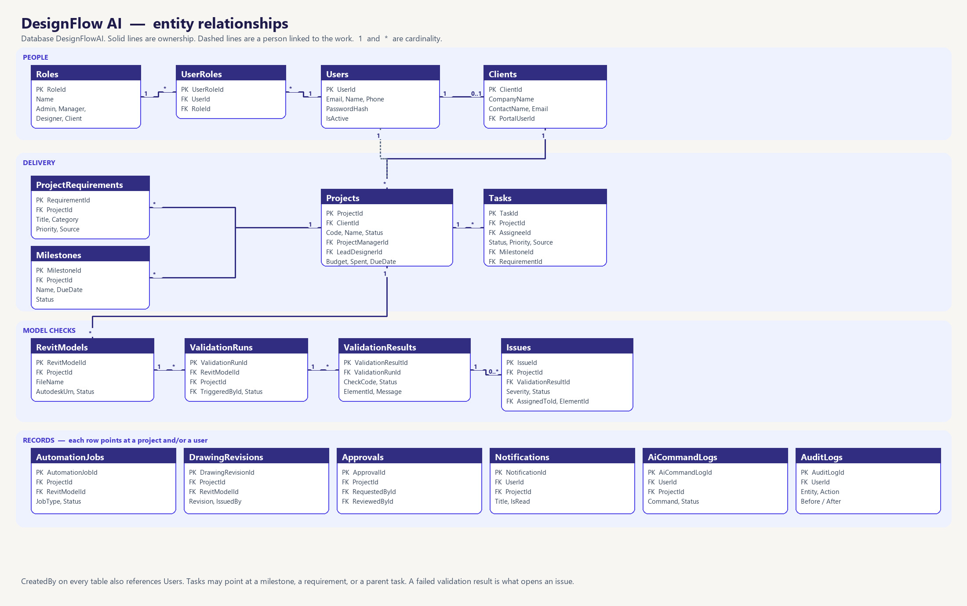
Figure 1. DesignFlowAI entities and the main foreign keys.
6. Relationship list
From | To | Link
Roles | UserRoles | One role is held by many user-role rows.
Users | UserRoles | One user can hold more than one role.
Users | Clients | A client login is stored in PortalUserId. Staff users have no client row.
Clients | Projects | One client has many projects. A project has one client.
Users | Projects | ProjectManagerId and LeadDesignerId each point at a user.
Projects | ProjectRequirements | Scope items parsed from the brief or typed by the team.
Projects | Milestones | Schedule points such as concept, model, and issue.
Projects | Tasks | Delivery work. A task may also point at a milestone, a requirement, or a parent task.
Users | Tasks | AssigneeId is the designer. ApprovedBy is the manager who accepted an AI plan.
Projects | RevitModels | One project can have many synced Revit files.
RevitModels | ValidationRuns | Each plugin check pass is one run, also tied to the project and the user who triggered it.
ValidationRuns | ValidationResults | One row per check. Status is Pass or Fail.
ValidationResults | Issues | A failed result opens an issue. The issue also stores the project, the model, and the assigned designer.
Projects | AutomationJobs | Translation and other Autodesk jobs. Optional link to a Revit model.
Projects | DrawingRevisions | Issued drawing sets, optional link to the Revit model and the user who issued them.
Projects | Approvals | Manager decisions. RequestedById and ReviewedById point at users.
Users | Notifications | Alerts for a person. Optional ProjectId.
Users | AiCommandLogs | What someone asked the assistant, and the project it referred to.
Users | AuditLogs | Who changed which record.

7. Seeded projects
Code | Project | Client | Lead designer
NW-2BHK-001 | Sharma Residence — Modern 2BHK | Rahul Sharma, Northwind Residences | Arjun Mehta
HB-LOFT-014 | Harbor Loft Renovation | Sofia Alvarez, Harbor & Co | Lena Ortiz
LM-LOBBY-007 | Lumen Lobby Concept | Priya Nair, Lumen Hospitality | Arjun Mehta

Sharma is the project with two open issues from a failed validation run: a door missing its fire rating, and a room without a name. Harbor has an overdue cove-lighting task. Currency in the seed data is INR.
8. Where the files are
Folder | Contents
Desktop\AI project\frontend | Angular studio.
Desktop\AI project\DesignFlowAI\backend | API solution: Domain, Application, Infrastructure, Api, Tests.
Desktop\AI project\DesignFlowAI\database | SQL scripts, seed data, and DesignFlowAI.bak.
Desktop\AI project\DesignFlowAI\revit-addin | Revit plugins and the install script for 2025 and 2026.

Autodesk and AI provider keys stay in API user-secrets. They are not stored in the Angular app and they are not written in this brief.

